How to create a new module for OPUS

Copy an existing module
In Eclipse, select an existing module (such as the UCM module), copy and paste.
Select a name for the new module. In this document, the 'mozambique' module is created as an example.
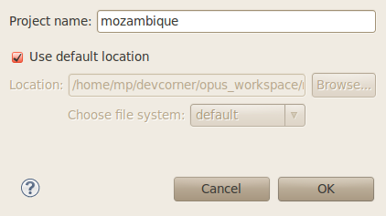Illustration 1: Copy Project

Disconnect new module from team repository
Right click → Team → Disconnect
Make sure to delete SVN meta data.
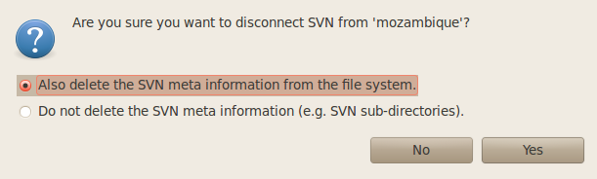Illustration 2: Disconnect from repository

Remove, rename and adapt files
Remove unnecessary source code files; adapt license headers and Spring files, etc.
Rename packages, and search and replace all files with appropriate names.
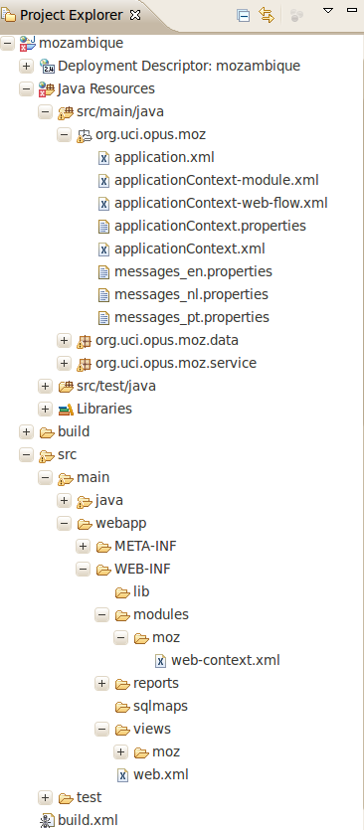

Create an ant script
In the opus project, add a new application entry that includes the new project.
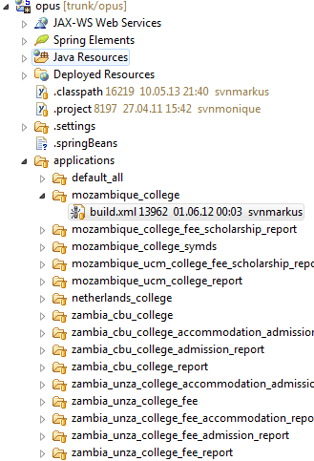Illustration 3: New application build script
<?xml version="1.0"?>
<project name="eSURA_college_mozambique"
basedir="."
default="all">

<path id="modules">
<pathelement location="${basedir}/../../../college"/>
<pathelement location="${basedir}/../../../mozambique"/>
</path>

<import file="${basedir}/../../common-build/application-targets.xml"/>

</project>
Table 1: build.xml

Check in new module to SVN repository
Check in the new module to the trunk of the SVN repository:
http://www.opuscollege.net/svn/opus/trunk/<module name>

